**COIT20273: Software Development Project**

**Term 1, 2021**

**Assignment 3- Progress Report A**

**Lecturer / Tutor: Indra Seher**

**Unit Coordinator: Lily Li**

**Prepared by:**

**Bishal Budhathoki (12116421)**

**Laxman Khanal (12123129)**

**Niraj Prasad Timila (12125320)**

**Raken Shahi (12119317)**

Table of Contents

**Summary** 3

**Changes made** 3

**Current Status** 4

**Schedule Overview** 8

**Risk Overview** 8

**Challenges Faced and Lessons Learned** 8

**Future Work** 8

# **Summary**

At this movement, we have successfully overcome most of our challenges we faced during our past performance. We are now almost back on track and finalized our UI including backend functionalities.

# **Changes made**

As we were almost doing well, very few changes were made on our project.

The only change we have made is to not include the google sign in/signup because the users can register with their existing email.

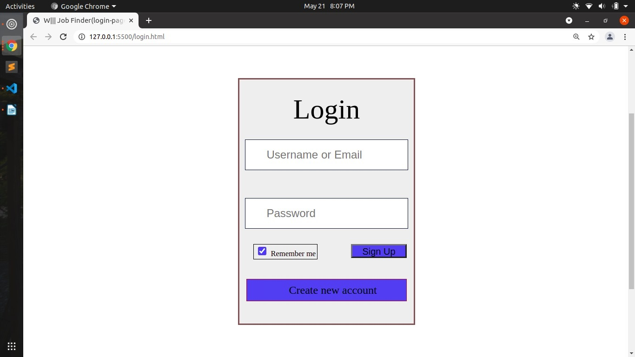

Google Sign/Signup Button Removed

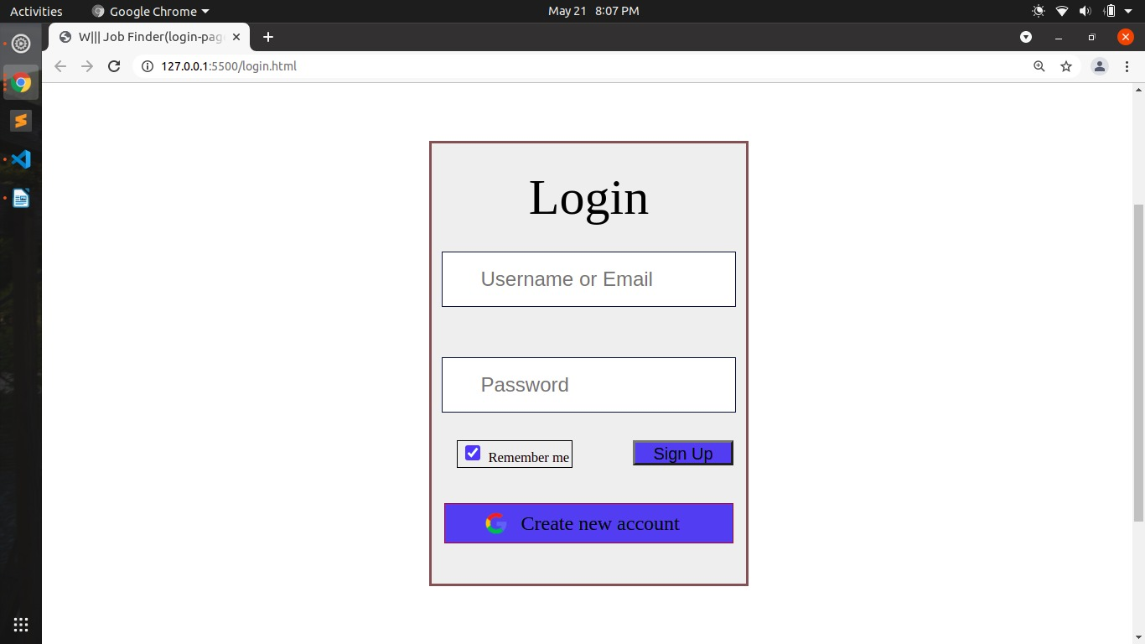Google Sign/Signup Button before

# **Current Status**

Nowadays we have been conducting our regular meeting twice a week so that we can be on track and we are progressing much more than before. Some of our modules are already completed and some are in progress. Beside that our login authentication system setup is completed as well. The database schema is ready and connected to MySQL database with node.js successfully.

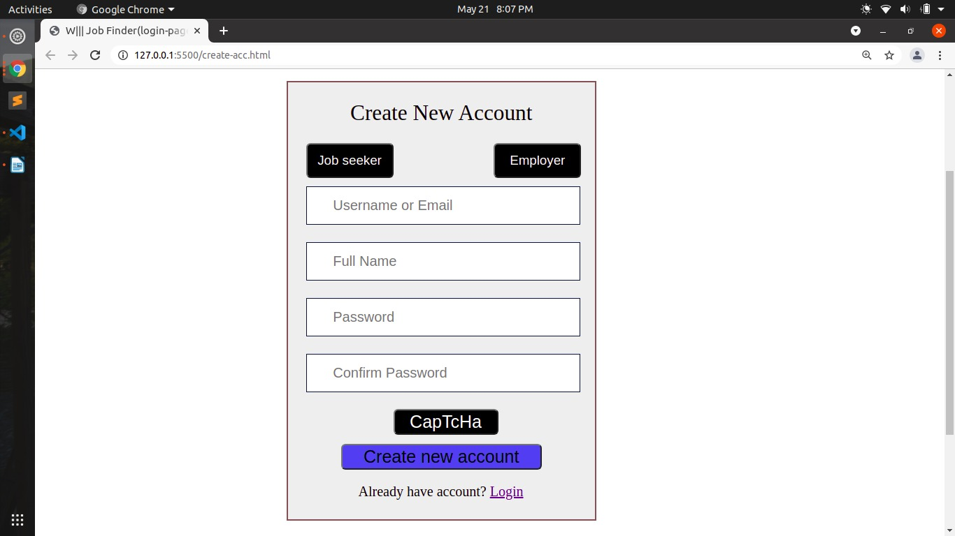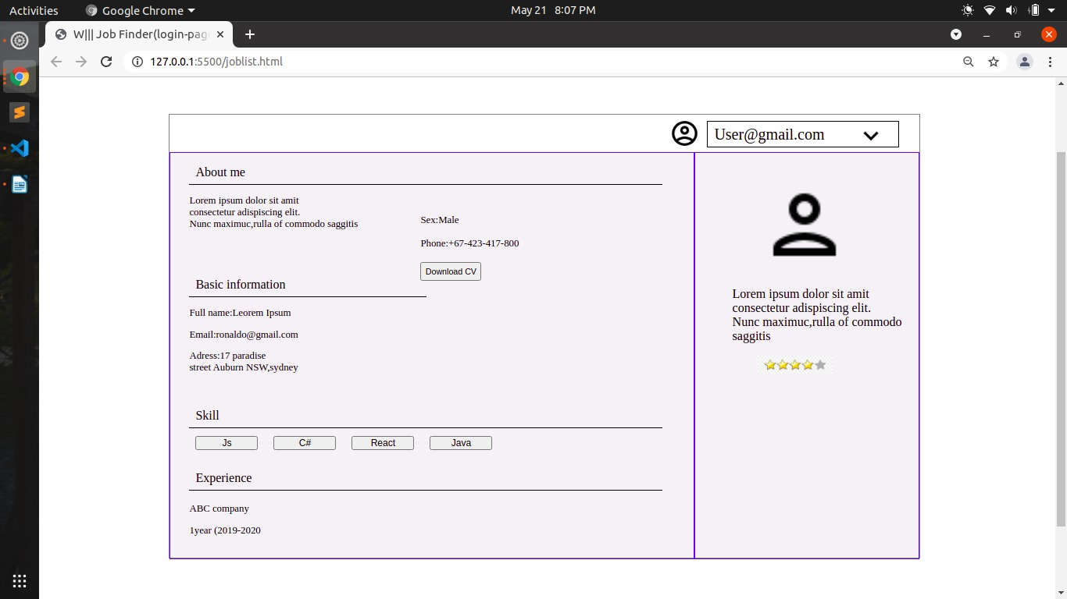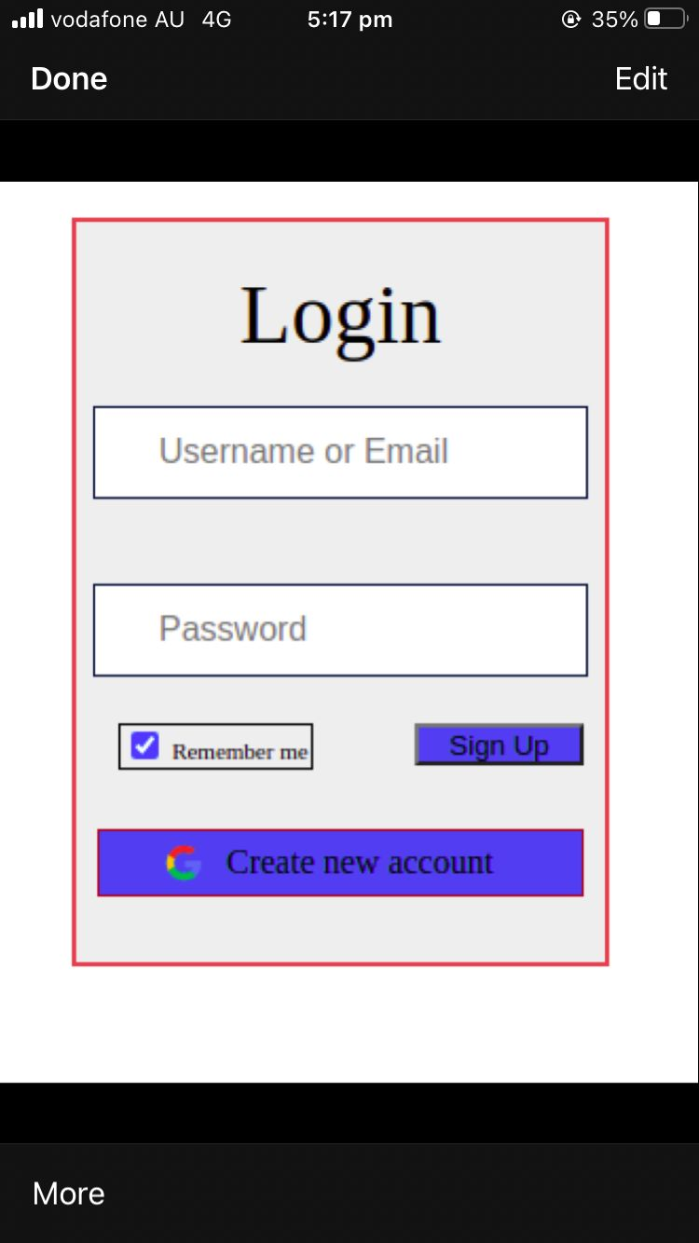

# **Schedule Overview**

We have made a compulsory schedule for everyone to complete their part of the task on time. Most members have reached their milestone and only a member is there who is also almost to his milestone. Everyone is communicating well and are being responsive.

# **Risk Overview**

Despite of all our commitment, communication and clear set of plans we have following risk factors:   
- We are at the edge of completing our semester so have a high pressure of assignments which may impact on the timeline for the project.   
- React and Node being new tech stack for all of us we don’t know how long it will take to resolve probable bugs.

# **Challenges Faced and Lessons Learned**

Now that we have solved our time issue and we are facing issues with bugs in the code, APIs implementation. We have also faced issues on uploading the files to the database and few logical errors. Online study and tutorial materials are very useful and should be completed till the end to get the best result.

# **Future Work**

We are now planning to get our database sort out specially with our uploading phase. Almost all the modules are ready, so the next phase is to integrate all and make it a complete system. Then after that we are up with the testing phase along with the documentation and reporting.